Pycharm Installation and Path Setup

3.1 Python Installation Page 1

3.2 PyCharm Installation Page 17

3.3 Create new Python project Page 22

IDE tools

3 Ways :

1. Interpreter
2. Command prompt (Notepad++, Editplus) > Windows+R -> cmd => python filename.py
3. IDE Integrated Development Environment Pycharm**
   1. **Python Installation :**

## How to Check if You Have Python Installed in Your Windows Operating System

Open the **CMD** or **PowerShell** and check the version of Python by using this command:

python --version

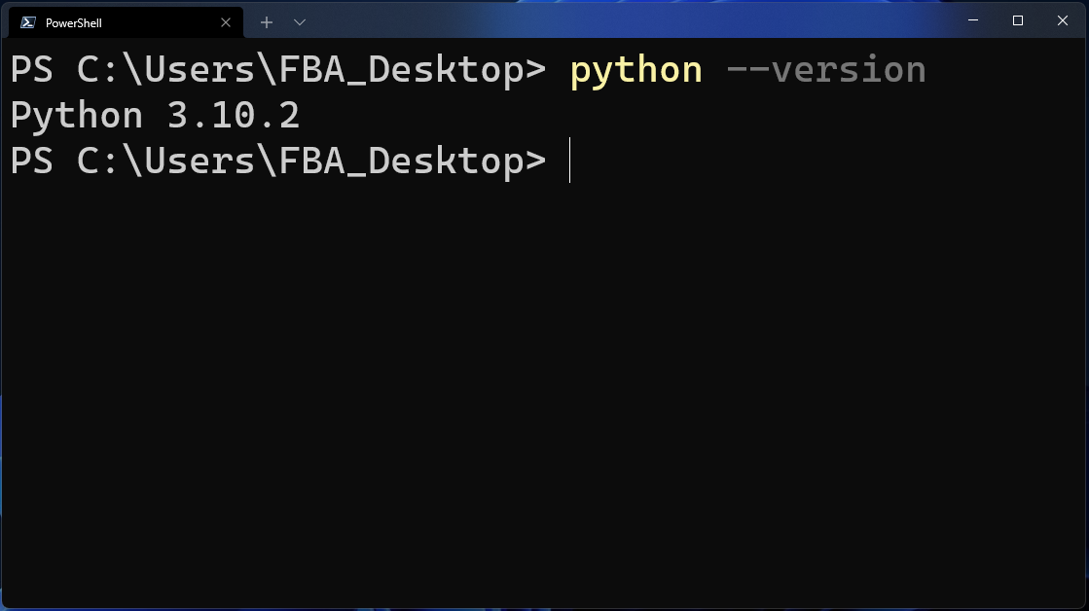

If you get the version of Python in the output like you see above, then your computer is perfectly okay for running any Python program. In your case, the version of Python might be different.

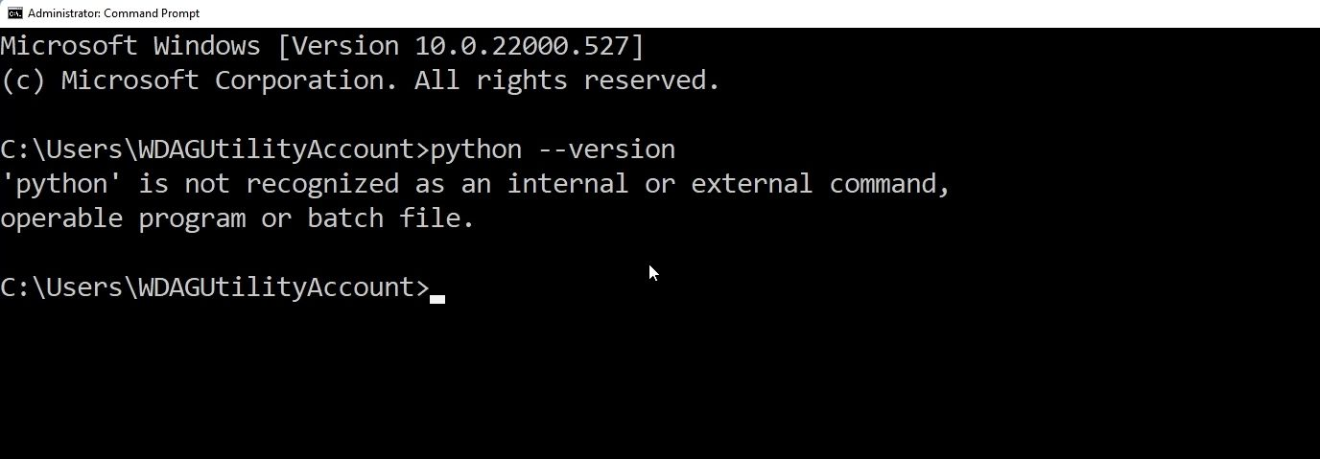

But if you get this type of output that you see above, then it can mean any of the following:

1. You did not have Python installed on your computer, or
2. Python's directory has not been added to the path of the **Environment Variables**.

For now let me assume that you do not have Python installed in your computer. Then I will also introduce you how you can add Python's directory to the path of the Environment Variables later in this article.

## How to Install Python on Windows

First of all, we need to go to the [official website of Python](https://www.python.org/).

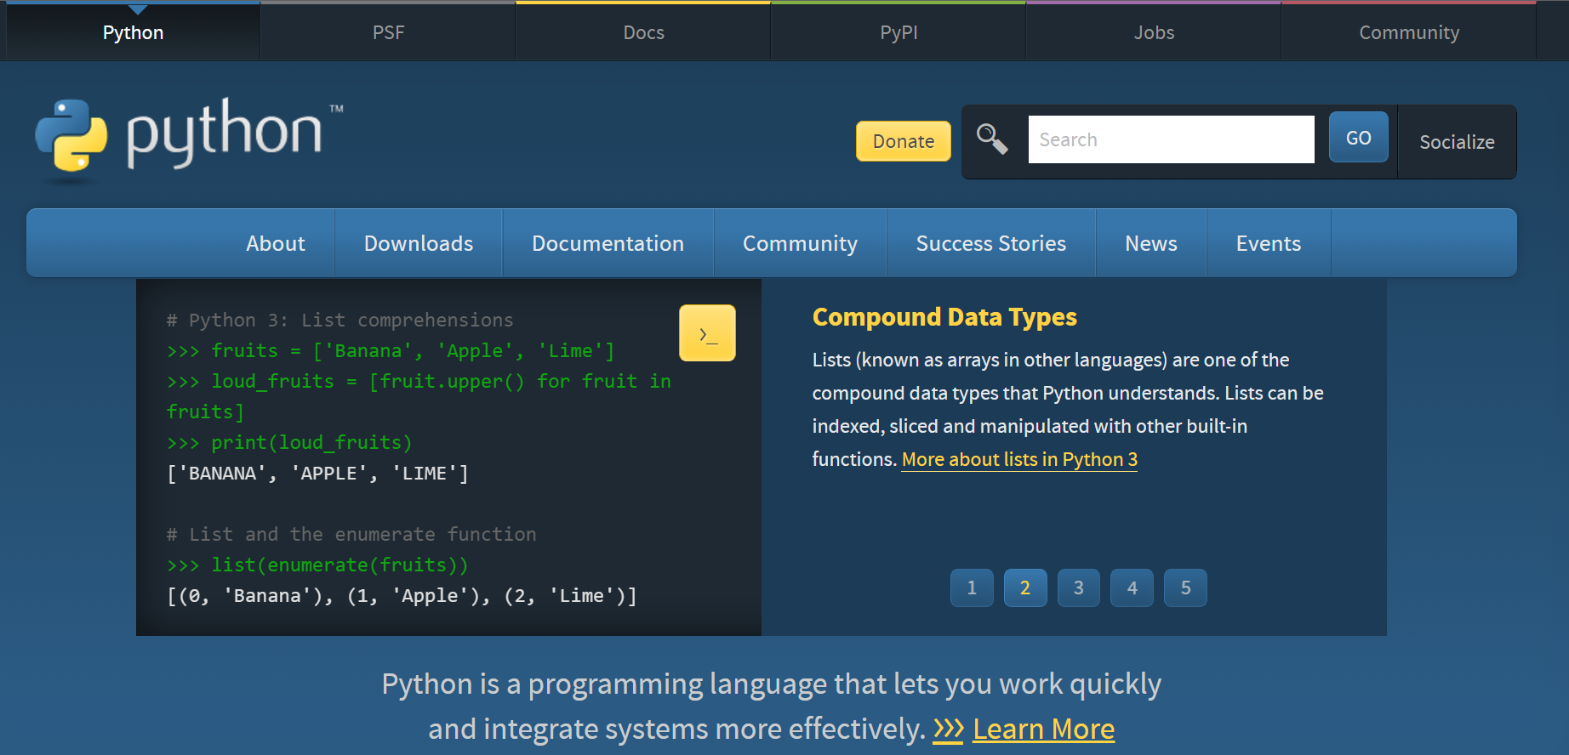

Click on the **Downloads** section.

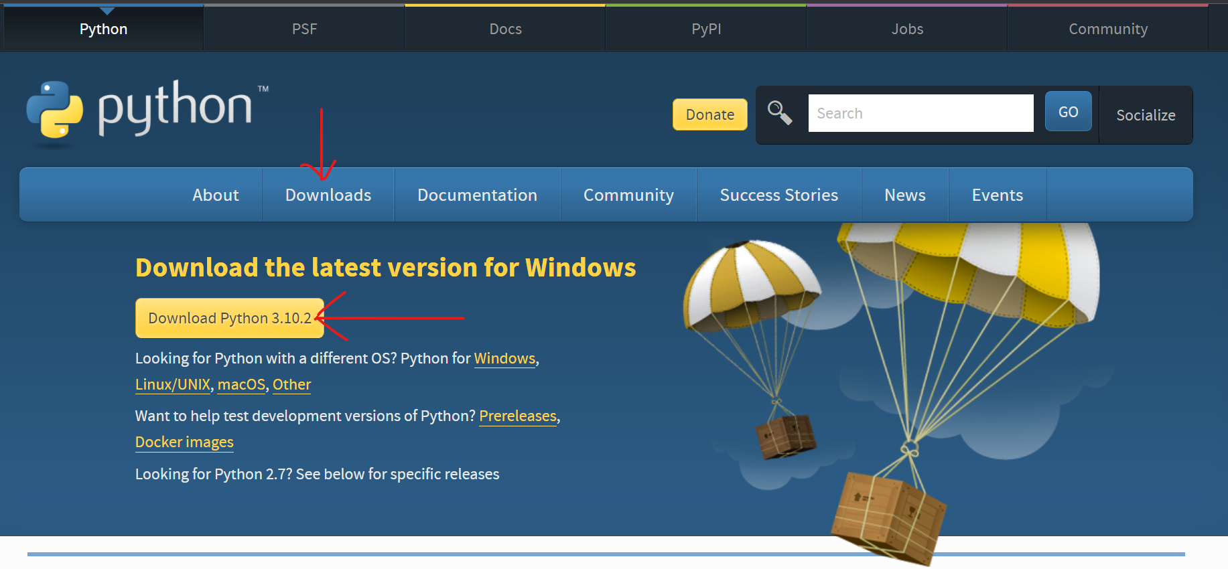

Here you will get the latest version. Just click on the Download Python 3.10.2. By the time you are reading this article, Python might have been updated, in which case the version would be different. Simply download the version it shows you.

Keep in mind that here it will always show you the latest version of Python at the top.

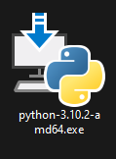

After downloading the file, we will get an executable file like this. Simply double click on that file and the installation wizard will open.

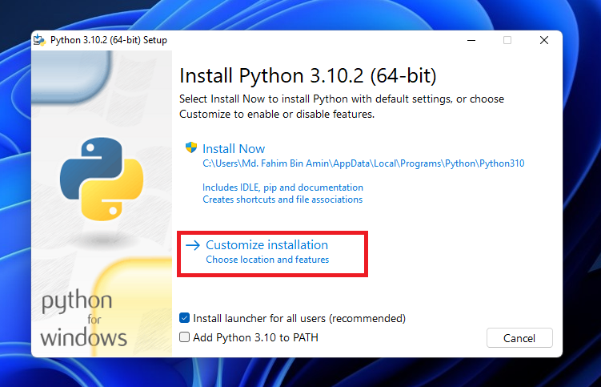

**Do not forget to check the Add Python 3.10 to PATH or else you have to add the PATH manually.**

Click on Customize installation.

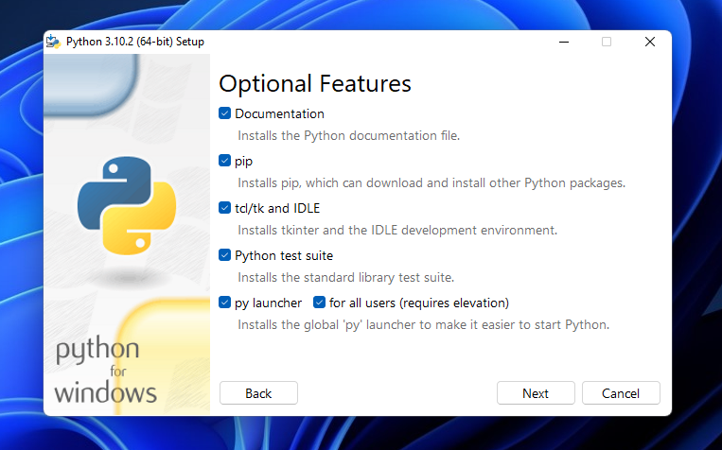

Make sure to check all of the boxes, like above. Then click Next.

Then you'll see the below screen. If you want, then you can check all of the boxes. I do not need the debugging symbols and the debug binaries. So, I will not check the last two boxes.

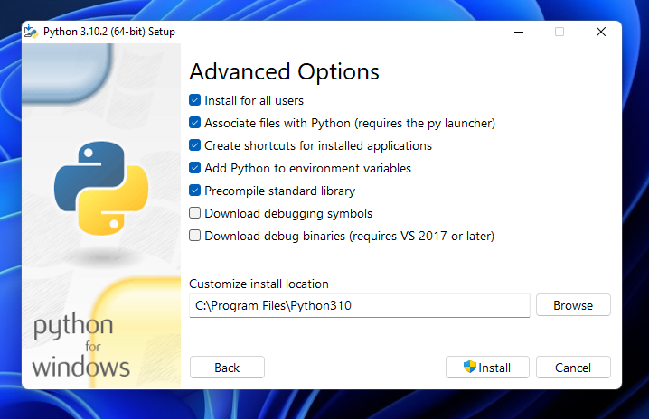

I would also recommend that you not change the location of the installation. Remember the install location as you might need that later. We are adding Python to the environment variables here directly.

Then click Install.

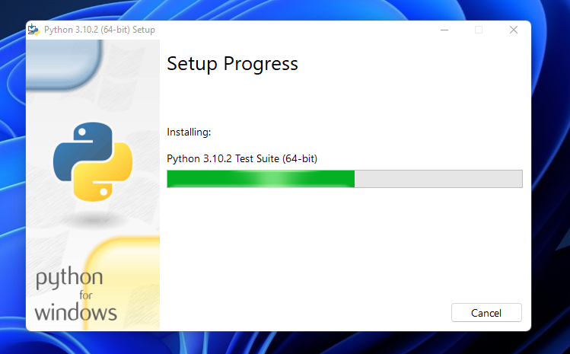

Let the installation process finish up...



If you get this type of prompt to disable the path length limit, then simply click on that box. It disables the path length limit by removing the limitation on the MAX_PATH variable.

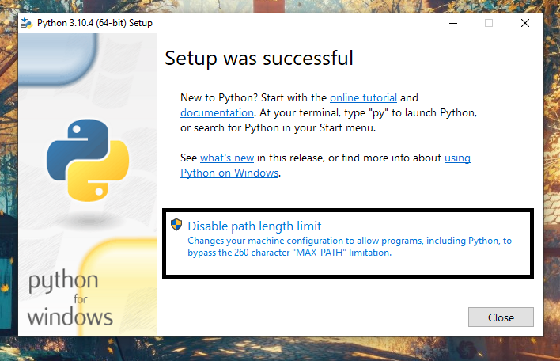

This change will not break anything, or make any negative changes. It will just allow Python to use long path names. It is recommended to disable the path length limit.

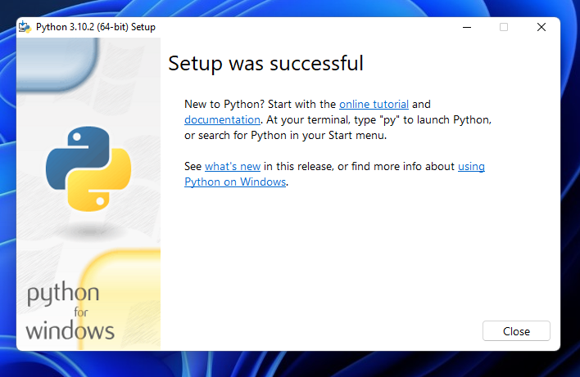

The installation has been finished successfully.

## How to Check the Python Version

Now we need to check again whether Python has been successfully installed and added to the path of the environment variables or not.

To check that, we need to open the **CMD** or the **PowerShell**. Then we need to apply the following command:

python --version

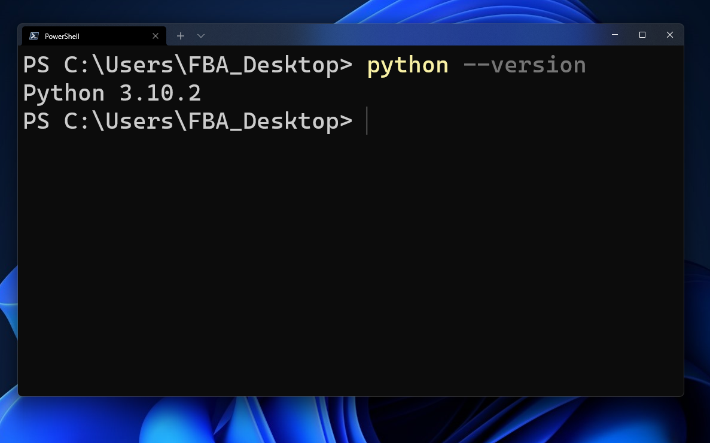

Python has been installed and the path has also been added in the environment variables successfully!

## How to Check the Path of the Environment Variables

If you want to check the path variables manually, then you have to open the Advanced System Settings. You can either search for Advanced System Settings, or you can open that from the **Control Panel** as well.

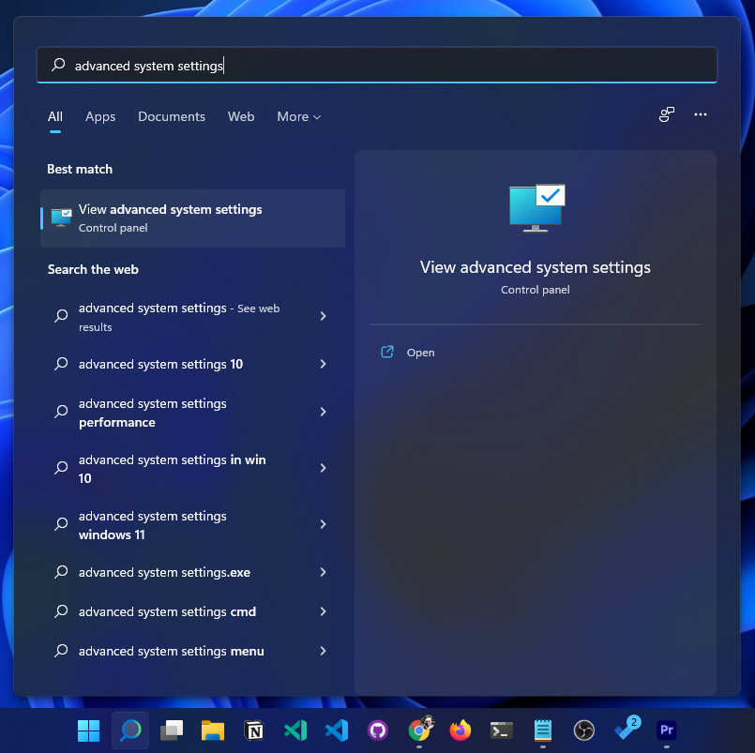

If you search using the keyword Advanced system settings, you will get that directly here like this.

If you want to open that from the **Control Panel**, then, first of all, you need to open the control panel.

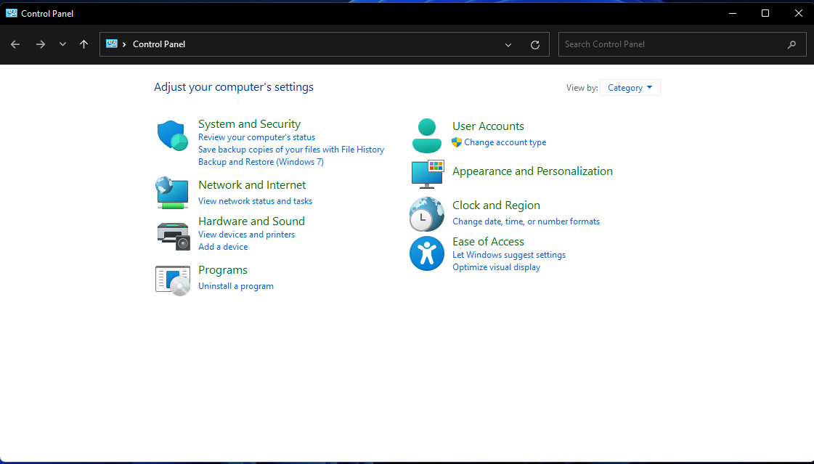

Go to System and Security.

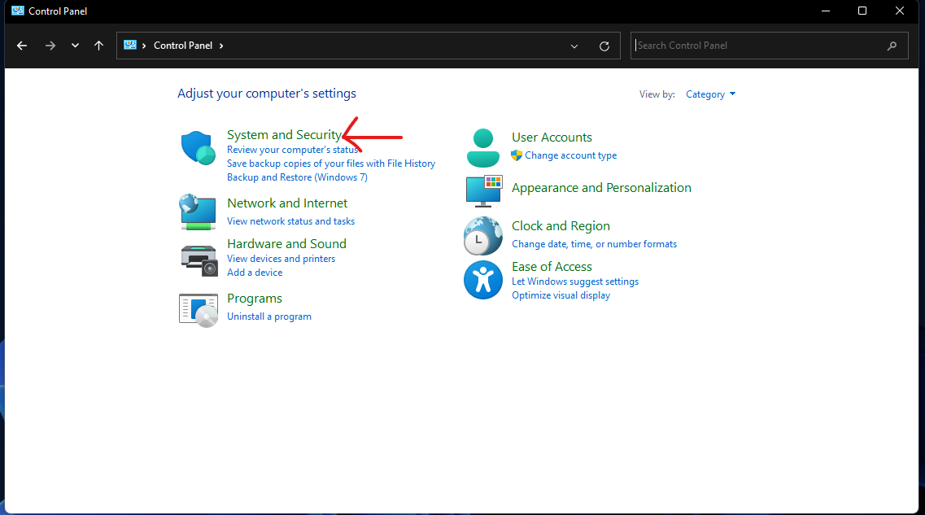

Click on System.

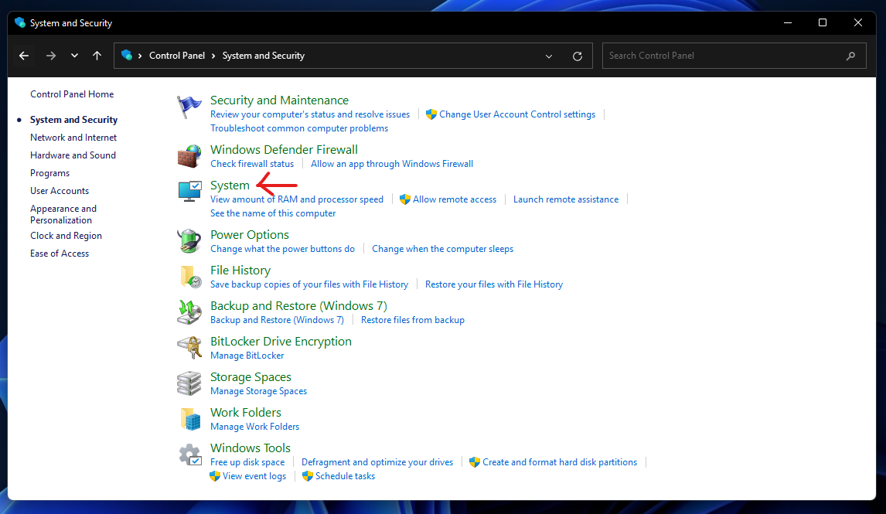

From here, click on Advanced System Settings.

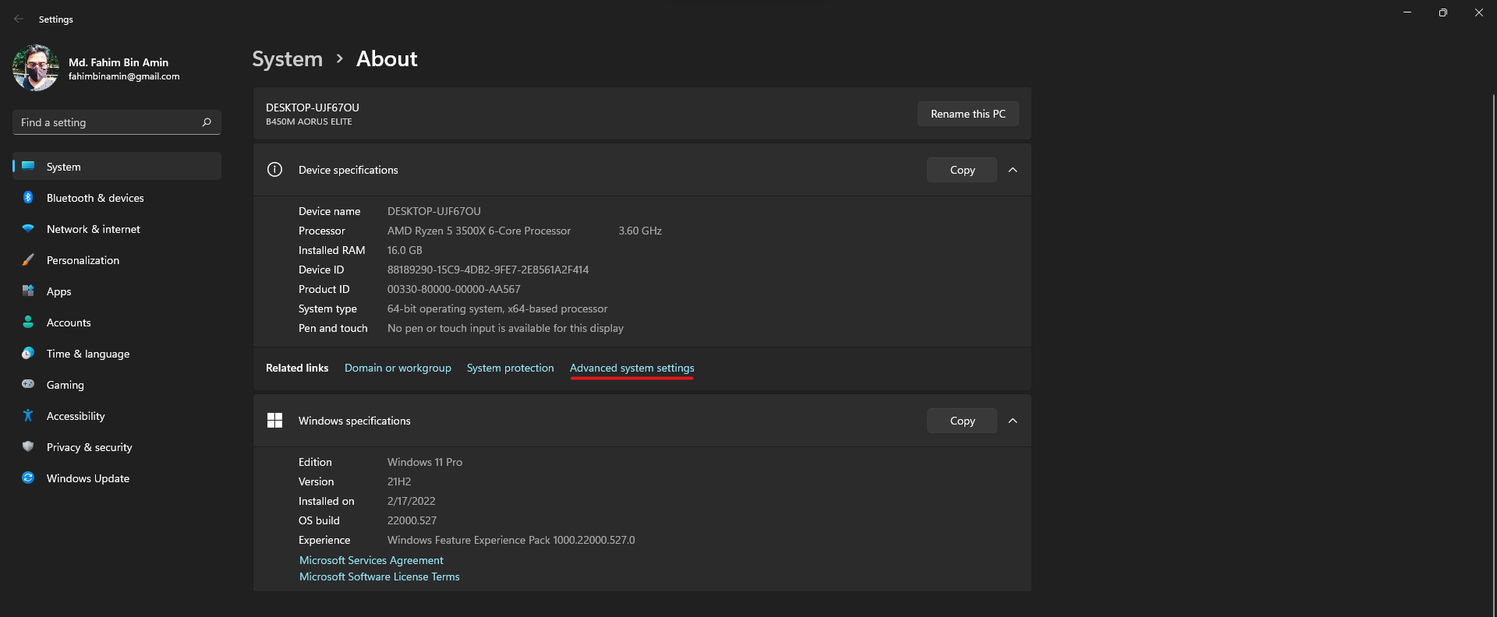

Click on Environment Variables.

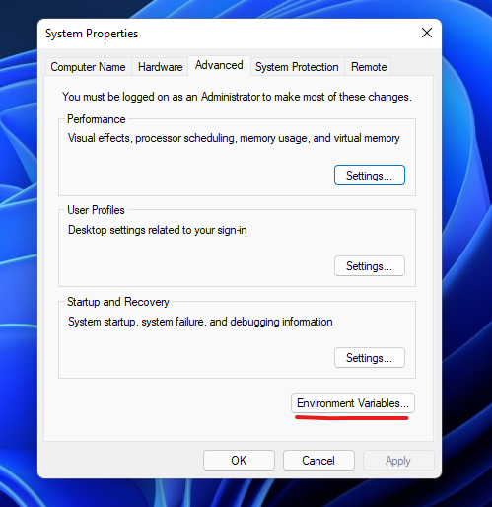

Click on Path and then click Edit.

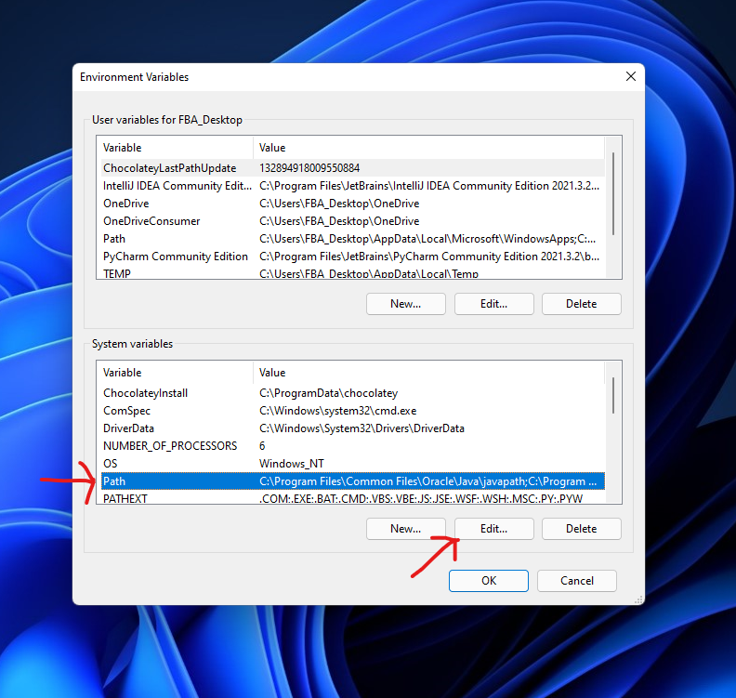

You will see that the root directory of **Python310** and the **scripts directory** of Python310 have already been added in the installation process, as we checked the box to do these during the installation.

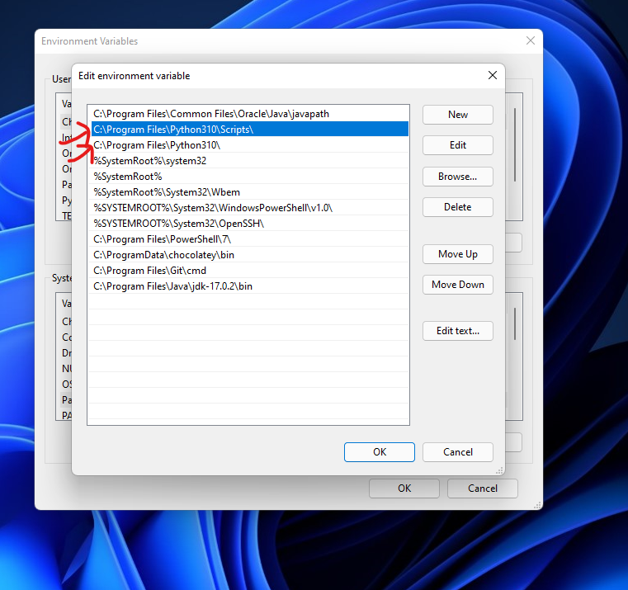

If you wanted to do that manually, then you would need to copy and paste the two directories here by clicking New and pasting the two directories into two blank boxes (one box appears each time you click New). Then simply click on OK to all of the opened boxes and close all the opened windows.

**3.2 PyCharm Installation:**

Step 1

Download the required package or executable from the official website of PyCharm <https://www.jetbrains.com/pycharm/download/#section=windows>Here you will observe two versions of package for Windows as shown in the screenshot given below −

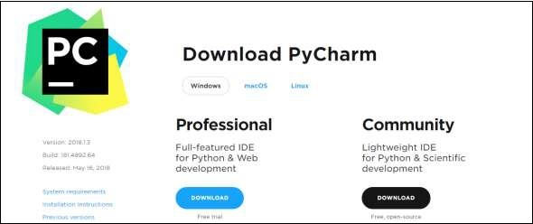

Note that the professional package involves all the advanced features and comes with free trial for few days and the user has to buy a licensed key for activation beyond the trial period. Community package is for free and can be downloaded and installed as and when required. It includes all the basic features needed for installation. Note that we will continue with community package throughout this tutorial.

Step 2

Download the community package (executable file) onto your system and mention a destination folder as shown below −

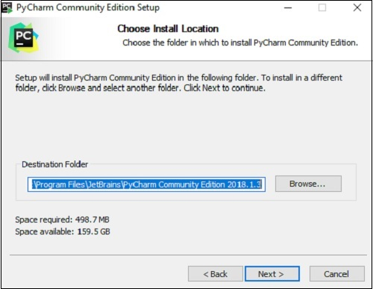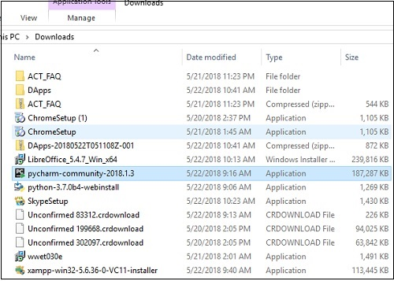

Step 3

Now, begin the installation procedure similar to any other software package.

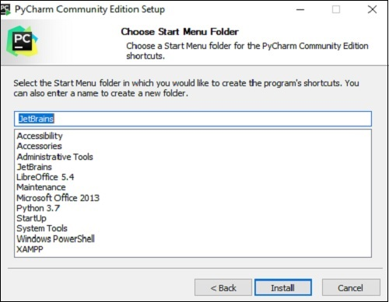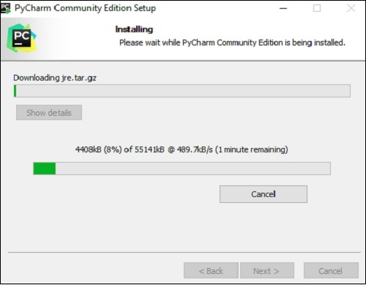

Step 4

Once the installation is successful, PyCharm asks you to import settings of the existing package if any.

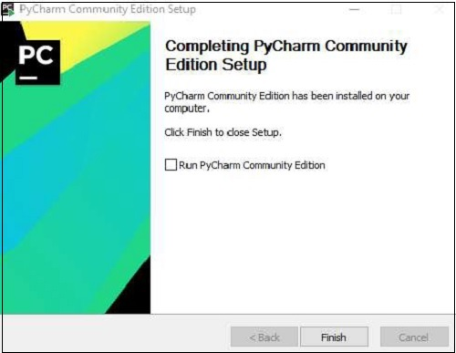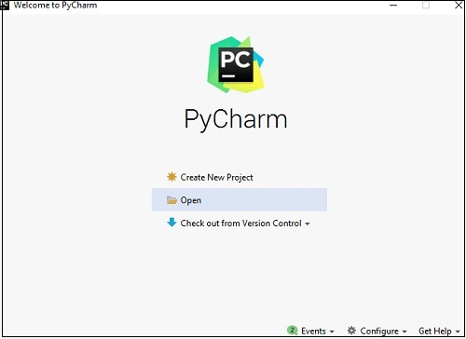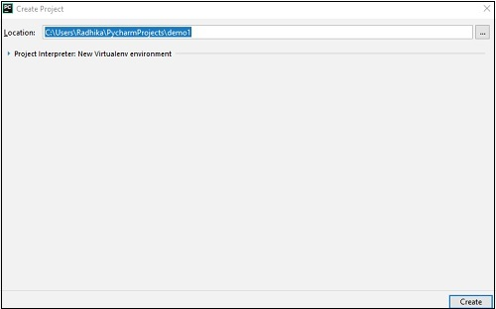

This helps in creating a new project of Python where you can work from the scratch. Note that unlike other IDEs, PyCharm only focusses on working with projects of Python scripting language.

**3.4 Create new Python Project in PyCharm:**

1. Click “Create New Project” in the PyCharm welcome screen.  
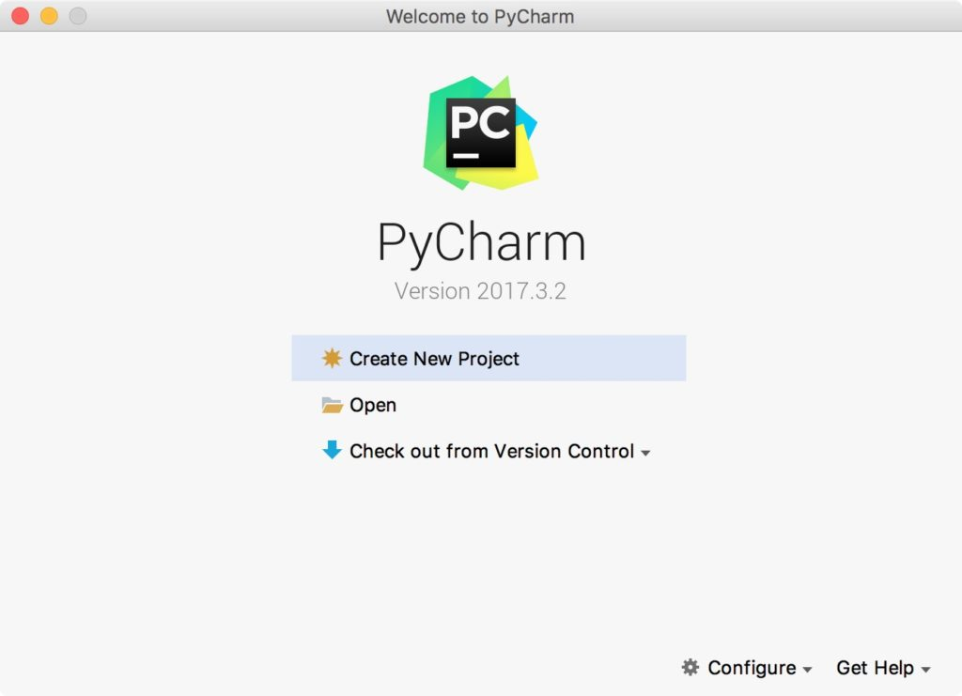

2. Give a meaningful project name.  
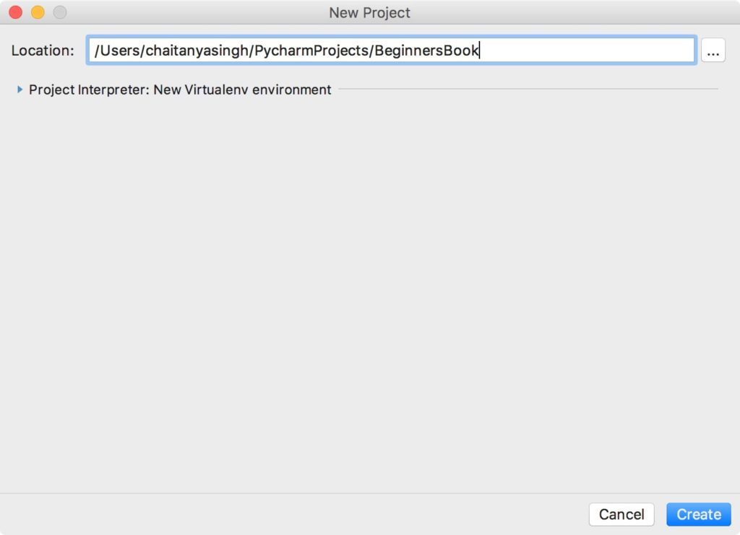

## Writing and running your first Python Program

1. Now that we have created a Python project, it’s time to create a Python program file to write and run our first Python program. To create a file, right click on the folder name > New > Python File (as shown in the screenshot). Give the file name as “HelloWorld” and click ok.  
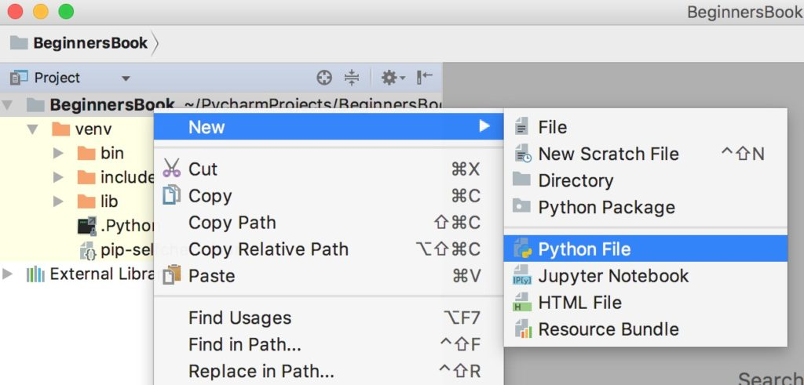

2. Write the following code in the file.

# This Python program prints Hello World on screen

print('Hello World')

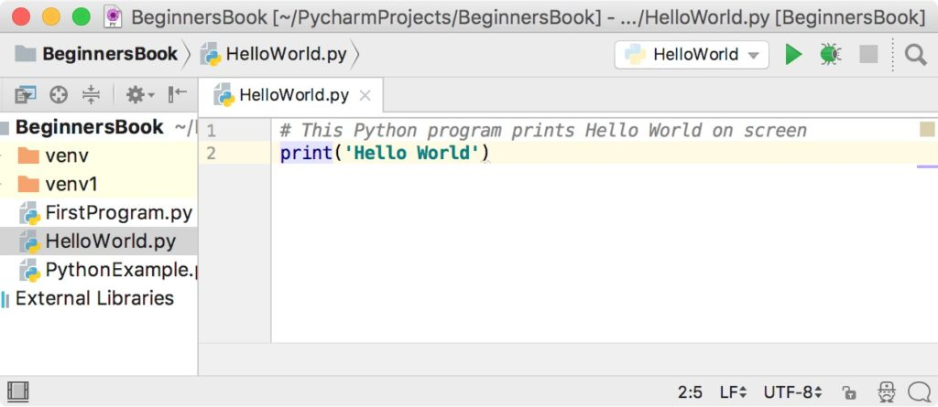

3. Lets run the code. Right click on the HelloWorld.py file (or the name you have given while creating Python file) in the left sidebar and click on ‘Run HelloWorld’.  
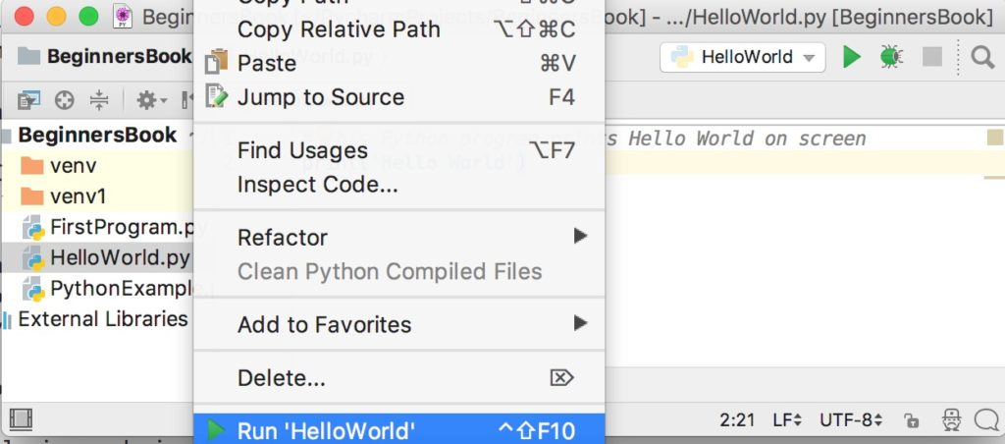

4. You can see the output of the program at the bottom of the screen.  
